ASSIGNMENT – 4 [08-12-2023]

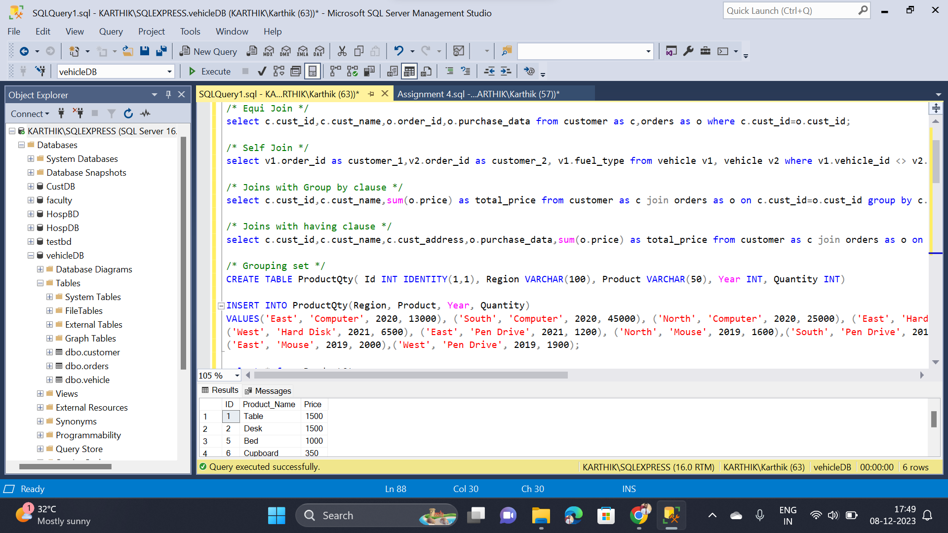BY Karthikeyan K R

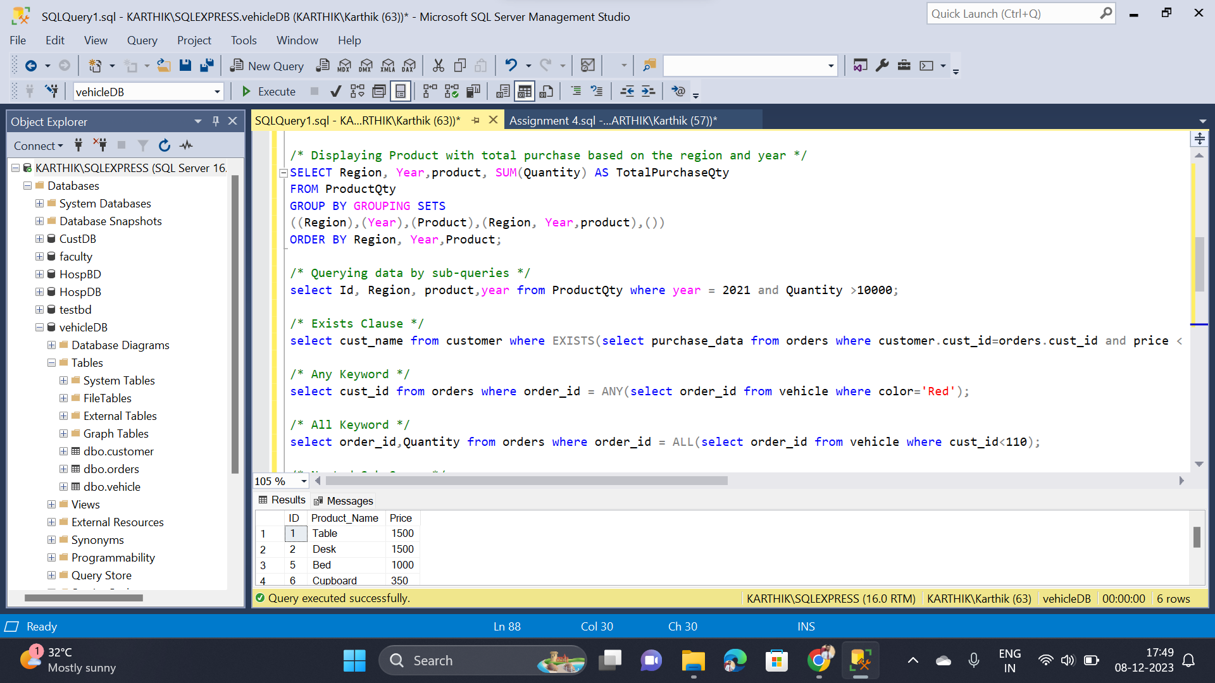

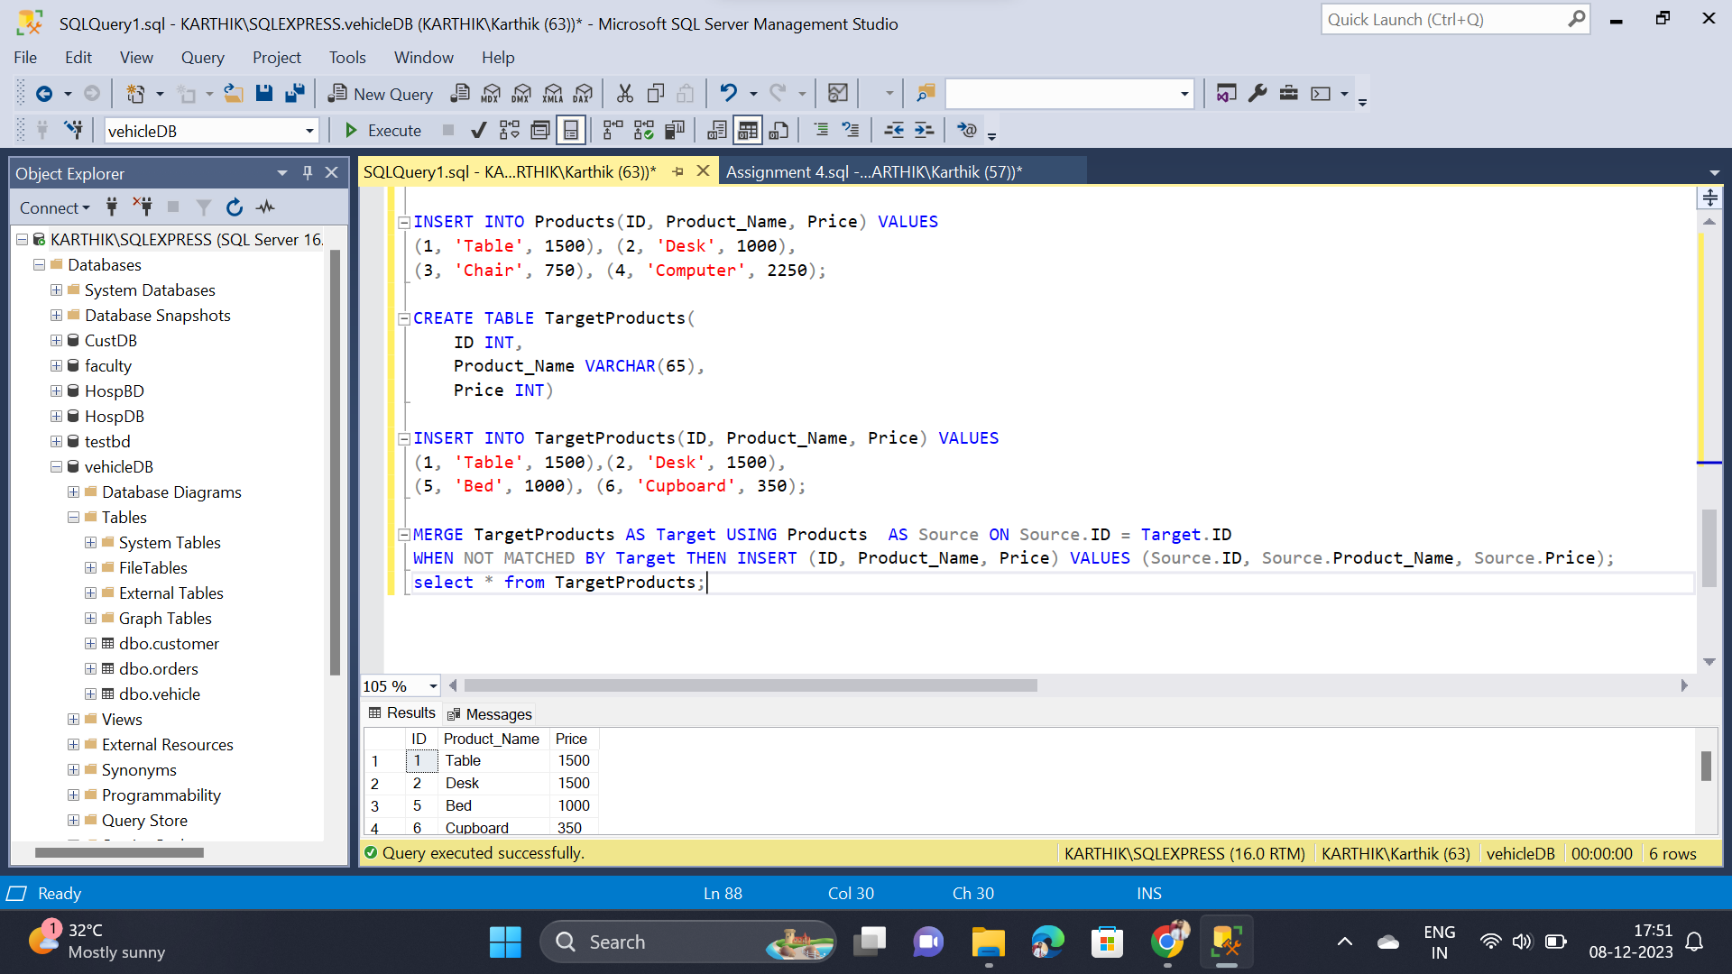

* Completed Equi and Self Joins
* Completed Joins with Group clause
* Completed Joins with Having clause
* Completed Grouping Sets
* Completed Sub-Queries and Nested Sub-Queries
* Completed Exists, Any, All and Merge